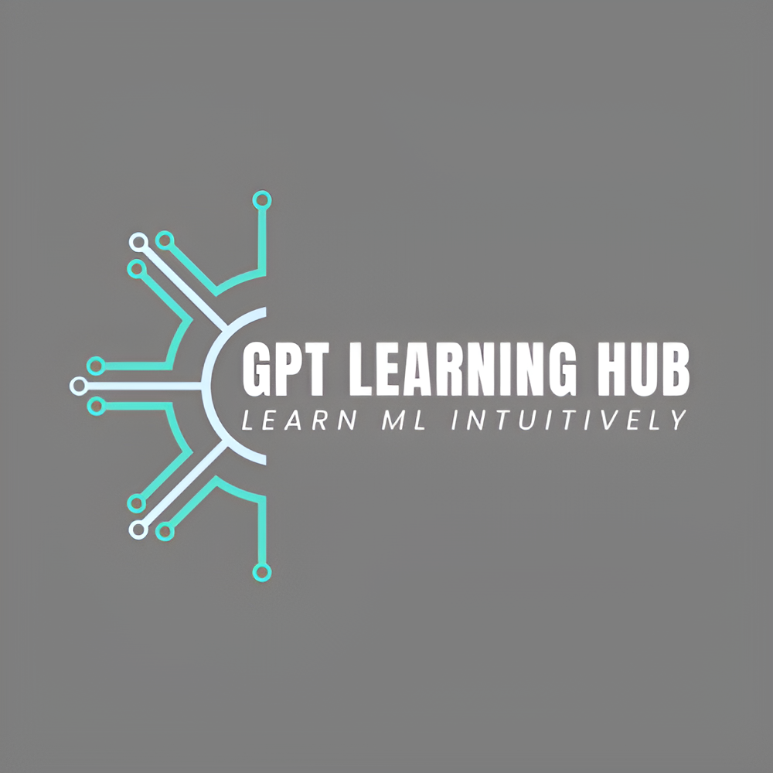

GPT Learning Hub

horizontal line

# 50 More AI/ML Projects.

No BS projects for college students.

by Dev G

You want to build, but every time you sit down to code, your brain stalls.

"What should I build?”

“Is it too basic?”

“Too complicated?”

The cycle continues, and you end up doing nothing.

This guide is your antidote to project paralysis. A gift from me to you.

With 50 unique yet practical projects, you’ll never run out of ideas again.

Just pick one that you like and get building!

P.S. [Check out Liftoff here if you haven’t yet. The price is increasing very soon.](https://llms.gptlearninghub.ai/)

## **Computer Vision**

### **Beginner**

1. **Lazy Landmark Finder** - Train a model to recognize famous landmarks from the laziest angles (low effort, blurry shots, bad lighting).
   * Use a pre-trained CNN like ResNet or MobileNet, fine-tune it with a dataset of bad-angle landmark images, and deploy with OpenCV.
2. **Pet Mood Detector** - Use OpenCV to detect if your cat or dog looks happy, angry, or existentially puzzled.
   * Collect labeled pet facial expression images, train a simple CNN, and integrate with a webcam for real-time detection.
3. **Messy Desk Scanner** - Identify the messiest part of your desk and rate it on a chaos scale.
   * Train an object detection model like YOLO to detect clutter and assign a messiness score based on object count.
4. **Emoji Face Swap** - Swap human faces with their closest emoji lookalike in real-time.
   * Use dlib for facial landmark detection, match expressions with an emoji dataset, and swap using OpenCV.
5. **Fake Vintage Filter Generator** - Train a model to apply vintage filters that mimic actual old film camera defects.
   * Use style transfer with a GAN trained on old film textures and apply distortions programmatically.

### **Intermediate**

1. **AI-Powered Spot-the-Difference** - Generate ‘spot-the-difference’ games automatically from two nearly identical images.
   * Use image segmentation and feature detection to highlight differences.
2. **Art Style Transfer for Stick Figures** - Convert hand-drawn stick figures into Van Gogh, Picasso, or anime styles.
   * Train a neural style transfer model with paired stick figure and artistic-style datasets.
3. **Security Cam Ghost Detector** - Detect “ghosts” (false positives like curtains moving) from security footage.
   * Train a motion detection model with OpenCV and filter non-human movements.
4. **AI That Judges Your Outfit** - An AI fashion critic that rates how fashionable (or questionable) your outfit is.
   * Use a fashion dataset and train a CNN classifier to rate outfits.

### **Advanced**

1. **Self-Repairing Images** - An AI model that fixes and fills in missing or damaged parts of an image automatically.
   * Train a GAN for inpainting using incomplete images as input.
2. **Object Eraser for Videos** - Train an AI to remove unwanted objects from moving video frames.

* Use DeepFill or other inpainting GANs combined with object tracking.

1. **Automated Speed Painting Coach** - AI that suggests what to change in your painting based on famous artists' styles.

* Train a style transfer model with reinforcement learning on user feedback.

1. **AI-Powered Visual Lies** - Create optical illusions dynamically by altering images to trick human perception.

* Use adversarial networks to generate misleading but plausible images.

1. **Synthetic Reality Generator** - Generate completely synthetic but believable images of cityscapes, planets, or creatures.
   * Train a GAN on diverse landscape datasets to generate new realistic images.
2. **AI-Powered Kaleidoscope** - Generate symmetrical, trippy patterns based on real-world objects.
   * Apply Fourier transformations and symmetry-based filters on images.

### **Natural Language Processing (NLP)**

**Intermediate**

1. **AI Shakespeare Translator**
   * Train a seq2seq model with parallel datasets of modern and Shakespearean English. Fine-tune with transformer models.
2. **Passive-Aggressive Email Rewriter**
   * Use sentiment analysis with transformers (like BERT) to detect tone, then rewrite using a fine-tuned GPT model.
3. **AI-Powered Bedtime Storyteller**
   * Train a text-generation model like GPT on children’s books and fairy tales. Add user input prompts for customization.
4. **Meeting Summarizer for the Zoned-Out**
   * Use speech-to-text (like Whisper) to transcribe audio, then summarize key points with a transformer model.
5. **AI-Generated Motivational Quotes**
   * Fine-tune a GPT model on famous motivational quotes and mix in randomness to generate deep-sounding phrases.

**Advanced**

1. **AI Debate Partner**
   * Train a model on argument datasets and fine-tune a conversational AI like ChatGPT to argue both sides of an issue.
2. **AI That Talks Like You**
   * Train an LLM on personal writing samples to mimic your writing style. Fine-tune with reinforcement learning for improved accuracy.
3. **AI-Generated Stand-Up Comedy**
   * Use GPT fine-tuned on stand-up routines, incorporating joke structures and comedic timing.
4. **Meme Caption Generator**
   * Train a vision-language model (like BLIP or Flamingo) on meme datasets to generate relevant captions for images.
5. **AI That Detects Fake Apologies**
   * Train a sentiment analysis model on labeled apologies to detect sincerity, analyzing tone and phrasing.

### **Audio & Music**

**Beginner**

1. **AI Beatboxer**
   * Train a model on beatboxing audio clips, then generate sounds with a WaveNet-based vocoder.
2. **Humming-to-Song Converter**
   * Use pitch detection (like CREPE) to analyze hums and compare them with song databases for matches.
3. **AI That Makes Lo-Fi Beats**
   * Generate lo-fi beats using a neural network like Jukebox or RNN-based music generation.
4. **AI That Narrates Your Life**
   * Use real-time speech recognition (Whisper) and fine-tune a text-to-speech (TTS) model with expressive narration.
5. **Auto-Tune for Everyday Speech**
   * Implement pitch correction algorithms (like Auto-Tune) on real-time speech input.

**Intermediate**

1. **AI That Rewrites Song Lyrics**
   * Fine-tune a GPT model on song lyric datasets and use rhyme detection for coherence.
2. **AI That Detects Fake Accents**
   * Train a speech classification model on accent datasets and use phoneme analysis for accuracy.
3. **Music Mood Matcher**
   * Use sentiment analysis on voice input, then recommend songs from a mood-labeled dataset.
4. **AI That Recreates Lost Songs**
   * Train an LSTM or Transformer-based music model on melody sequences and reconstruct missing parts based on input clues.
5. **AI That Sings Your Texts**
   * Convert text to lyrics, then use a neural vocoder (like WaveNet) to generate sung output.

**Advanced**

1. **AI That Generates Entire New Instruments**
   * Use deep learning for sound synthesis (e.g., GANs for timbre generation) to create unique instrument sounds.
2. **AI That Writes Personalized Love Songs**
   * Train a model on love song lyrics and fine-tune it with user-provided preferences.
3. **AI-Generated Rap Battles**
   * Fine-tune an LLM on rap lyrics and train a model to generate bars that rhyme and flow like a real rapper.
4. **Speech-to-Melody Converter**
   * Extract pitch contours from speech and map them onto musical scales to generate melodies.
5. **AI Music Time Traveler**
   * Train a style transfer model on music from different eras to transform modern songs into historical styles.

### **Reinforcement Learning Projects**

#### **Beginner**

1. **Self-Tuning Alarm Clock**
   * Collect sleep data (wake-up times, snooze patterns) and use a simple Q-learning algorithm to adjust the alarm time based on reinforcement rewards (e.g., getting up on time). Implement a basic policy to balance between adjusting earlier or later.
2. **Boredom Buster**
   * Create a dataset of moods and activities, then train a Q-learning agent to predict the best activity based on user feedback (reward signals). Use epsilon-greedy exploration to balance new suggestions vs. known favorites.
3. **Auto-Skipper**
   * Process video frames using OpenCV to detect intros/outros. Train an RL model using Deep Q-Networks (DQN) to decide when to skip based on historical user interactions (e.g., manual skips as rewards).
4. **Game AI Trainer**
   * Build a simple RL agent that trains itself to play a classic game like Flappy Bird. Use OpenAI Gym to simulate the environment and a Deep Q-Network (DQN) to learn from game outcomes. Reward the agent for surviving longer and penalize it for collisions or losing conditions.

#### **Intermediate**

1. **Smart Playlist DJ**
   * Train an RL model using Reinforcement Learning with Bandit Algorithms to adjust songs dynamically based on user pace and biometric data (e.g., heart rate or motion sensors). Integrate with Spotify API for real-time playlist control.
2. **Traffic Light Optimizer**
   * Simulate a city grid with SUMO (Simulation of Urban Mobility) and train a Proximal Policy Optimization (PPO) RL agent to adjust signal timing based on real-time traffic flow and congestion data.
3. **Self-Driving Scooter**
   * Mount a camera and LIDAR on an RC scooter, preprocess images with OpenCV, and train a DQN agent in a simulated environment before transferring to the real scooter. Reward functions can be based on collision avoidance and efficient navigation.

#### **Advanced**

1. **AI Stock Market Manipulator (Ethical Edition)**
   * Use historical stock data and train a Deep Reinforcement Learning (DRL) agent using PPO or Advantage Actor-Critic (A2C) to model market trends. Train the model in a simulated trading environment like OpenAI Gym’s Stock Trading environment.
2. **Rogue AI in a Video Game**
   * Integrate an RL agent into a game engine like Minecraft (using MineRL) or GTA (via OpenAI Gym-GTA). Train using PPO or DQN with rewards for adapting to player behavior and executing unpredictable actions.
3. **Personalized Learning Assistant**
   * Train an RL agent to adjust content difficulty dynamically using Multi-Armed Bandits or Policy Gradient methods. Use user engagement data (quiz scores, time spent, etc.) as rewards to fine-tune personalized learning pathways.

horizontal line

GPT Learning Hub

San Jose, CA, 95128

P.S. [Check out Liftoff here if you haven’t yet. The price is increasing very soon.](https://llms.gptlearninghub.ai/)